*Florida International University*

*School of Computing and Information Sciences*

Software Engineering Focus

Final Deliverable

Project Title: Smart Billionaires 1.0

**Team Members: Josue Mirtil**

**Product Owner(s)**: Masoud Sadjadi

**Mentor(s)**: Masoud Sadjadi

**Instructor**: Masoud Sadjadi

The MIT License (MIT)

Copyright (c) *2016 Florida International University*

Permission is hereby granted, free of charge, to any person obtaining a copy of this software and associated documentation files (the "Software"), to deal in the Software without restriction, including without limitation the rights to use, copy, modify, merge, publish, distribute, sublicense, and/or sell copies of the Software, and to permit persons to whom the Software is furnished to do so, subject to the following conditions:

The above copyright notice and this permission notice shall be included in all copies or substantial portions of the Software.

THE SOFTWARE IS PROVIDED "AS IS", WITHOUT WARRANTY OF ANY KIND, EXPRESS OR IMPLIED, INCLUDING BUT NOT LIMITED TO THE WARRANTIES OF MERCHANTABILITY, FITNESS FOR A PARTICULAR PURPOSE AND NONINFRINGEMENT. IN NO EVENT SHALL THE AUTHORS OR COPYRIGHT HOLDERS BE LIABLE FOR ANY CLAIM, DAMAGES OR OTHER LIABILITY, WHETHER IN AN ACTION OF CONTRACT, TORT OR OTHERWISE, ARISING FROM, OUT OF OR IN CONNECTION WITH THE SOFTWARE OR THE USE OR OTHER DEALINGS IN THE SOFTWARE.

***Abstract***

*This document presents the information necessary to gain a good understanding of the MQL5 program and the Zone Recovery Algorithm. The project is based on the algorithm constructed by Joseph Nemeth and his team. Joseph posted a YouTube video explaining the algorithm and can be found at, https://www.youtube.com/watch?v=DJz4E7VyeSw.*

**Table of Contents**

**Introduction** …………………………………………………………………………………………………………………………….. 5

Current System ……….…………………………………………………………………………………………………………... 5

Purpose of New System …………………………………………………..…………………………………………………... 5

**User Stories**

Implemented User Stories ………………………………………….………………………………………………………..6

Pending User Stories …………………………………………………………………...………………………………..….. 10

**Project Plan**

Hardware and Software Resources ……………………………………………………...……………………….… 11

Sprints Plan ……………………………………………………………..………………………………………………………. 12

*Sprint 1*  …………………………………………………………………………………………………………………………... 12

*Sprint 2*  …………………………………………………………………………………………………………………………... 13

*Sprint 3*  …………………………………………………………………………………………………………………………... 13

*Sprint 4*  …………………………………………………………………………………………………………………………... 14

**System Design**

Architectural Patterns ………………………………………………………………………………………………….. 14

System and Subsystem Decomposition …………………………………………………………………………….… 15

Deployment Diagram …………………………………………………………………………………………………….…... 16

Design Patterns ………………………………………………………………………………………………………….….... 16

**System Validation**  …………………………………………………………………………………………………………………….17

**Glossary**  ………………………………………………………………………………………………………………………………….18

**Appendix**  ………………………………………………………………………………………………………………………………….19

Appendix A - UML Diagrams ………………………………………………………………………………………………. 19

*Static UML Diagrams*  ……………………………………………………………………………………………………….19

*Dynamic UML Diagrams*  …………………………………………………………………………………………………..20

Appendix B - User Interface Design …………………………………………………………………………….…... 23

Appendix C - Sprint Review Reports …………………………………………………………………………...…… 23

Appendix D - User Manuals, Installation/Maintenance Document, Shortcomings/Wishlist Document and other documents …………………………………………………………………….…………… 25

**References** ……………………………………………………………………………………………………………………...………...28

# 

# Introduction

Zone Recovery is a revolutionary algorithm developed by Joseph Nemeth. He is a successful trader and has found a way to experience no loss in trading. Zone recovery is based on simple principle and that is that the ForEx market can either go down or up. When the market condition changes, close position and take profit. Using Joseph’s setup to analyze the charts, there is a 75% chance that the predictions on the market will be correct. When it is not correct, that is when the zone recovery algorithm can be executed to counter losses. With this setup a stop loss is completely unnecessary. A full explanation of the algorithm can be found at <https://www.youtube.com/watch?v=DJz4E7VyeSw>.

## 

## Current System

In order for traders to utilize the zone recovery, they would have to constantly pay attention to all the necessary charts; such as heiken ashi, MACD, EMA trends, and the renko chart. Traders would have to determine by hand the proper market condition to enter the market, and manually open trades. Traders will also have to remain vigilant and exit the market when the proper time, base on the algorithm, arises.

## Purpose of New System

This new system will facilitate trading using the zone recovery. It is a fully automated approach to executing the zone recovery algorithm. It will constantly analyze the charts for the user and open and close trades properly based on the zone recovery algorithm.

# User Stories

The following section provides the detailed user stories that were implemented in this iteration of the Smart Billionaires 1.0 project. These user stories served as the basis for the implementation of the project’s features. This section also shows the user stories that are to be considered for future development.

## Implemented User Stories

1. Implement Zone Recovery
2. Implement Entry Condition Check
3. Implement Exit Criteria
4. Implement Indicators for Heiken Ashi
5. Implement Indicators for MACD

### Implement Zone Recovery

As an expert adviser, I want to use the recovery zone so that I can open opposite trades and counter losses.

**Use Cases:**

**Name:** Buy Long

**Actors**: ExpertAdvisor, Terminal, TradeSignal

**Entry Condition**: Exit Market with no profit and market conditions at entry is no longer the case. See Use Case, Enter Market.

**Flow of Events**:

1. The terminal will send an ontick event
2. The ExpertAdvisor will open a long condition.

**Exit Condition**: The use case terminates when the ExpertAdvisor the trade is complete.

**Name:** Begin Zone Recovery

**Actors**: ExpertAdvisor, Terminal, TradeSignal

**Entry Condition**: Use case Buy Long

**Flow of Events**:

1. The terminal will send an ontick event
2. The ExpertAdvisor will check the heiken ashi for the current price.
3. The ExpertAdvisor will check with the tradesignal if the position should be closed.
4. The trade signal will justify close the position
5. The ExpertAdvisor will close the hedging sequence

**Exit Condition**: The use case terminates when the ExpertAdvisor closes the position, a new reverse position is opened, or the expert advisor returns no action.

**Alternate Flow**:

4A: The market went in the other direction past the recovery zone

1. The trade signal will not justify closing the trade
2. The ExpertAdvisor will check with the tradesignal if a new position should be opened.
3. The trade signal will justify opening a new position.
4. The ExpertAdvisor will open a new trade.

The use case terminates.

4B: The Market has not reached closing price, and is still in the same direction

1. The trade signal will not justify closing the trade
2. The ExpertAdvisor will check with the tradesignal if a new position should be opened.
3. The trade signal will not justify opening a new position.
4. The expert advisor will return no action.

The use case terminates.

### Implement Entry Condition Check

As the expert advisor, should be able to compare the heiken ashi and MacD in order to determine if the market condition is favorable to enter.

**Use Cases:**

**Name:** Analyze Heiken Ashi

**Actors**: ExpertAdvisor, TradeSignal

**Entry Condition**: The expert advisor is inserted into the terminal and has been initialized.

**Flow of Events**:

1. The terminal will send an ontick event
2. The expert advisor will query the TradeSignal for the color of the last bar of the heiken ashi chart
3. The TradeSignal will respond with an exit code signifying the color.

**Exit Condition**: The use case terminates when the ExpertAdvisor receives an exit code and prints result to terminal.

**Name:** Analyse EMA trend

**Actors:** ExpertAdvisor, TradeSignal

**Entry Condition:** The expert advisor is inserted into the terminal and has been initialized. The last bar of the heiken ashi is green.

**Flow of Events:**

1. The expert advisor will query the TradeSignal for the slope of the EMA trend and whether the price is above the EMA.
2. The TradeSignal will respond with an exit code signifying an upward slope and the relation of price to the EMA.

**Exit Condition**: The use case terminates when the ExpertAdvisor receives an exit code and prints result to terminal

**Name:** Analyse Renko Chart

**Actors:** ExpertAdvisor, Terminal, TradeSignal

**Entry Condition:** The expert advisor is inserted into the terminal and has been initialized. The last bar of the heiken ashi is green. The slope of the EMA trend is upward.

**Flow of Events:**

1. The expert advisor will query the TradeSignal for the color on the Renko chart and to verify with the MACD.
2. The TradeSignal will respond with an exit code signifying upward direction on the renko chart that has been verified by MACD

**Exit Condition**: The use case terminates when the ExpertAdvisorreceives an exit code and prints result to terminal

**Name:** Enter Market

**Actors**: ExpertAdvisor, Terminal

**Entry Condition**: The expert advisor is inserted into the terminal and has been initialized. There is no open position.The last bar of the heiken ashi is green. The slope of the EMA trend is upward. Upward direction on the renko chart that has been verified by MACD

**Flow of Events**:

1. The expert advisor will open a long position with ⅕ of the capital.
2. The terminal will provide a return code for the trade.

**Exit Condition**: The use case terminates when the ExpertAdvisor receives a return code and prints result to terminal

### Implement Exit Criteria

As an expert adviser, I want to read the Renko charts so that I can determine when to close the position.

**Use Cases:**

**Name:** Exit With Profit

**Actors**: ExpertAdvisor, Terminal, TradeSignal

**Entry Condition**: A position is open using the entry condition. The heiken Ashi changes color and there is profit.

**Flow of Events**:

1. The terminal will send an ontick event
2. The ExpertAdvisor will close the position.

**Exit Condition**: The use case terminates when the open position is closed.

**Name:** Improve Cost Basis

**Actors**: ExpertAdvisor, Terminal, TradeSignal

**Entry Condition**: A position is open using the entry condition. The heiken Ashi changes color and there is no profit. But the entry condition still holds.

**Flow of Events**:

1. The terminal will send an ontick event
2. The ExpertAdvisor will modify the position and increase volume.

**Exit Condition**: The use case terminates when the ExpertAdvisor the trade is complete.

**Name:** Exit With Zone Recovery

**Actors**: ExpertAdvisor, Terminal, TradeSignal

**Entry Condition**: A position is open using the entry condition. The heiken Ashi changes color and there is no profit. But the entry condition is no longer valid.

**Flow of Events**:

1. The terminal will send an ontick event
2. The ExpertAdvisor will enter use case, Begin Zone Recovery.

**Exit Condition**: The use case terminates when the use case Begin Zone Recovery ends.

### Implement Indicators for Heiken Ashi

As an Expert Adviser, I would like to read the bar on the Heiken Ashi chart so that I can determine Market trend

**Name:** Analyze Heiken Ashi

**Actors**: ExpertAdvisor, TradeSignal

**Entry Condition**: The expert advisor is inserted into the terminal and has been initialized.

**Flow of Events**:

1. The terminal will send an ontick event
2. The expert advisor will query the TradeSignal for the color of the last bar of the heiken ashi chart
3. The TradeSignal will respond with an exit code signifying the color.

**Exit Condition**: The use case terminates when the ExpertAdvisor receives an exit code and prints result to terminal.

### Implement Indicators for MACD

As an Expert Adviser, I would like to read the bar on the MACD chart so that I can determine Market trend

## Pending User Stories

All stories created were completed in this project.

# Project Plan

This section describes the planning that went into the realization of this project. This project incorporated the agile development techniques and as such required the sprints to be planned. These sprint plannings are detailed in the section. This section also describes the components, both software and hardware, chosen for this project.

## Hardware and Software Resources

The following is a list of all hardware and software resources that were used in this project:

**Hardware**

* Fully compatible with Windows machines running on Microsoft Windows XP SP3 SP3/2003/Vista/2008/7/8/10.
* Limited compatibility with MAC OS and Linux machines
* Required: A processor with SSE2 support (Pentium 4/Athlon 64 or higher)

**Software**

* MetaTrader 5
* Install Wine for MAC OS and Linux machines

## 

## 

## Sprints Plan

### Sprint 1

Attendees: Masoud Sadjadi

Kyle Roque

Josue Mirtil

Start time: 10:05 am

End time: 10:30 am

After discussion, the velocity of the team were estimated to be 40 (20+20).

The product owner chose the following user stories to be done during the next sprint. They are ordered based on their priority.

* User Story #663 Learn MQL5
* User Story #664 Learn ForEx

The team members indicated their willingness to work on the following user stories.

* Josue Mirtil
  + #663 Learn MQL5
  + #664 Learn ForEx
* Kyle Roque
  + #663 Learn MQL5
  + #664 Learn ForEx

### 

### Sprint 2

Attendees: Masoud Sadjadi

Kyle Roque

Josue Mirtil

Start time: 10:10 AM

End time: 10:45 AM

After discussion, the first thing to develop would be the missing required indicators.

The product owner chose the following user stories to be done during the next sprint. They are ordered based on their priority.

* #668 Implement Indicators for MacD
* #667 Implement Indicators for Heiken Ashi

The team members indicated their willingness to work on the following user stories.

* Josue Mirtil
  + #668 Implement Indicators for MacD
* Kyle Roque
  + #667 Implement Indicators for Heiken Ashi

### Sprint 3

It was decided to implement the full entry condition check and zone recovery.

The product owner chose the following user stories to be done during the next sprint. They are ordered based on their priority.

* #667 Implement Indicators for Heiken Ashi
* #669 Implement Entry Condition Check
* #670 Implement the Zone Recovery Activity

The team members indicated their willingness to work on the following user stories.

* Josue Mirtil
  + #667 Implement Indicators for Heiken Ashi
  + #669 Implement Entry Condition Check
  + #670 Implement the Zone Recovery Activity

### Sprint 4

It was decided to implement the final story, the exit criteria.

The product owner chose the following user stories to be done during the next sprint. They are ordered based on their priority.

* #671 Implement Exit Criteria

The team members indicated their willingness to work on the following user stories.

* Josue Mirtil
  + #671 Implement Exit Criteria

# System Design

This section contains information on the design decisions that went into this project. The architecture patterns are outlined and explained. The entire system is shown in a package diagram and the subsystems are explained. Finally, the design patterns used in the project are discussed.

## Architectural Patterns

The system follows the event driven architectural pattern. The Expert Adviser handles all events triggered by the terminal. The terminal triggers a tick event whenever there is new data on the chart. A timer event is triggered in a set interval of time. The timer is used to check market conditions if there is no open position. While the tick event is used to analyze the market to determine when to close or exit the market.

## System and Subsystem Decomposition

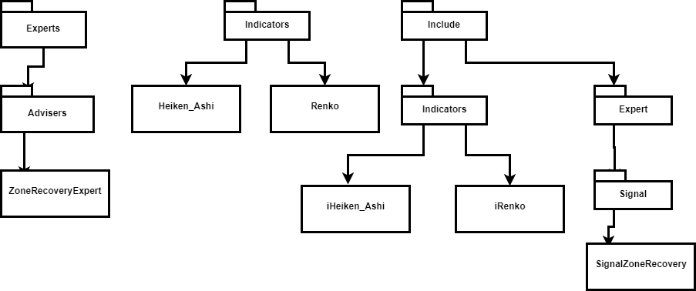

## Deployment Diagram

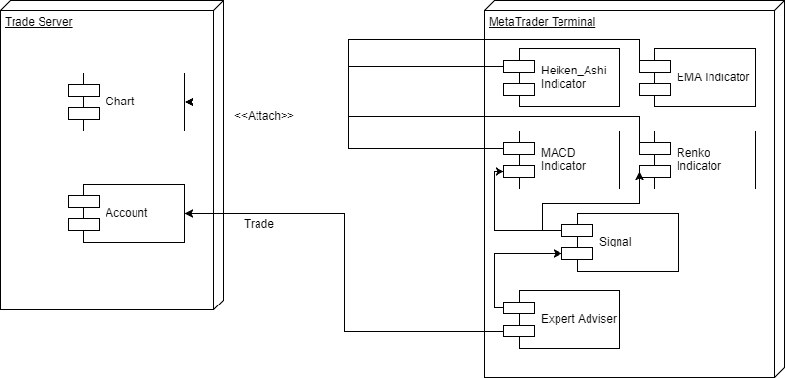

## Design Patterns

* Observer - As per the Event Driven Architectural Pattern, the Expert Adviser was built as an observer. Subscribed to the events of the MetaTrader Terminal.
* State - The Expert Adviser also had states to determine which exit rule it currently running.
* Object Oriented Design (OOD) - OOD was used for the expert adviser, signal, and indicator objects.

# System Validation

## Black Box Testing

Using the strategy tester provided by MetaTrader, tested the different Market Conditions when entering and exiting the market.

Enter Market :

* Scenario 1: Heiken Ashi bar green, positive slope on EMA trend, Renko bar green and validated by MACD.
* Scenario 2: Heiken Ashi bar red, positive slope on EMA trend, Renko bar green and validated by MACD
* Scenario 3: Heiken Ashi bar green, negative slope on EMA trend, Renko bar green and validated by MACD
* Scenario 4: Heiken Ashi bar green, positive slope on EMA trend, Renko bar red

Exit Market:

* Scenario 1: Renko red with profit
* Scenario 2: Renko red with no profit, entry condition still intact
* Scenario 3: Renko red with no profit, entry condition is not intact. Must enter zone recovery
* Scenario 4: The market is expected to go up, but turns down past recovery zone
* Scenario 5: The market is expected to go down, but turns up past recovery zone

# 

# Glossary

* Expert Advisor - application to automate analysis and trading
* Exponential Moving Average (EMA) - a type of moving average that is similar to a simple moving average, except that more weight is given to the latest data
* Heiken Ashi - a candlestick chart with different calculations than the typical candlestick chart.
* Indicator - application to display market information using a specific chart
* ForEx - Foreign Exchange Market
* MQL5 - language of trade strategies built-in the MetaTrader 5 Trading Platform
* Moving average convergence divergence (MACD) - a trend-following momentum indicator that shows the relationship between two moving averages of prices
* Trade Signal - Interface used by Expert Advisors to access Indicator data

# Appendix

## Appendix A - UML Diagrams

## Class diagram: Inheritance heirarchy and Associations.png

*Class Diagram - Inheritance Hierarchy and Associations*

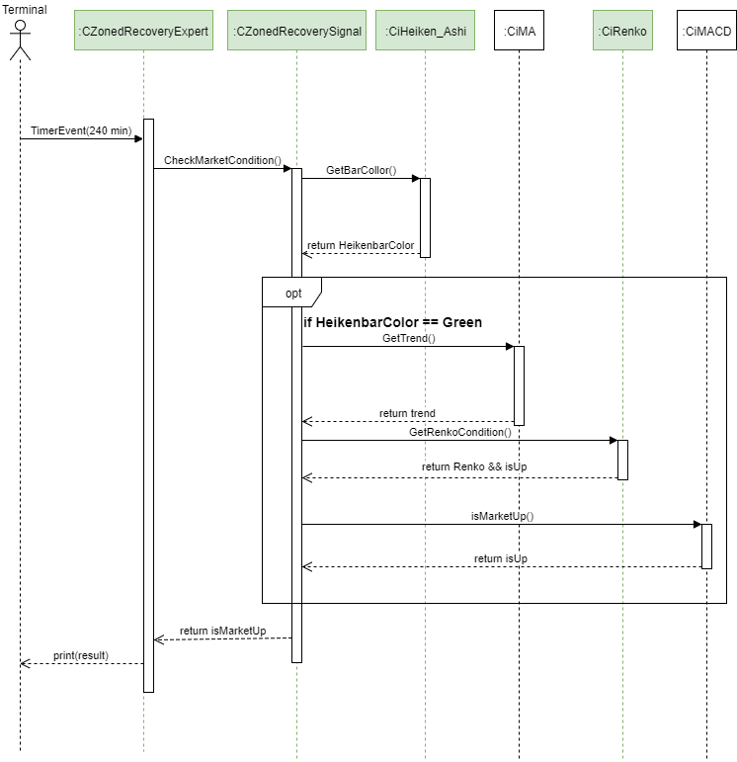

Entry Condition: Sequence Diagram

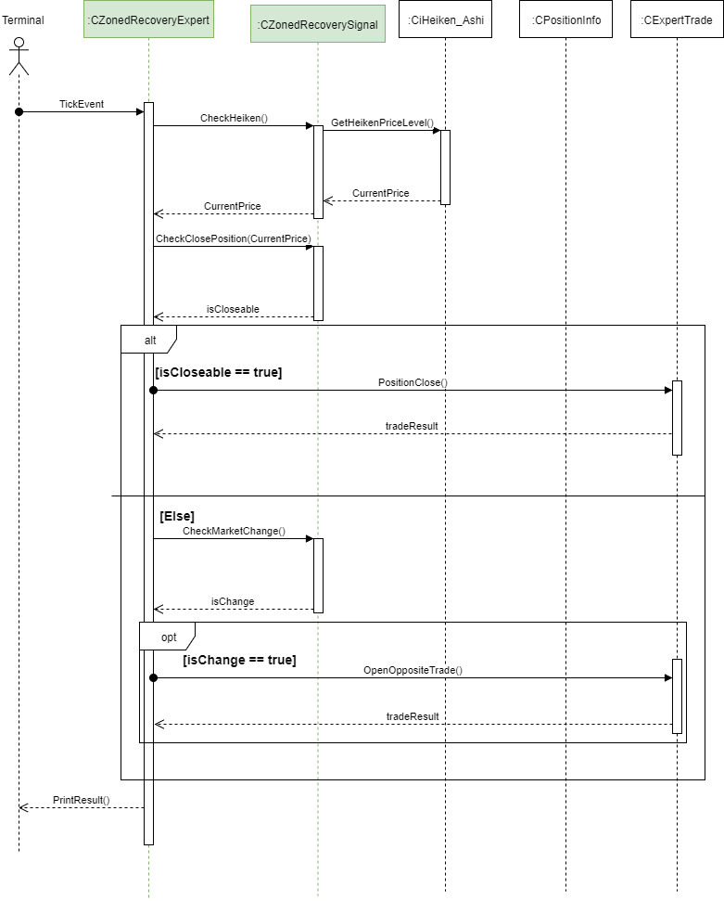

Zone Recovery: Sequence Diagram

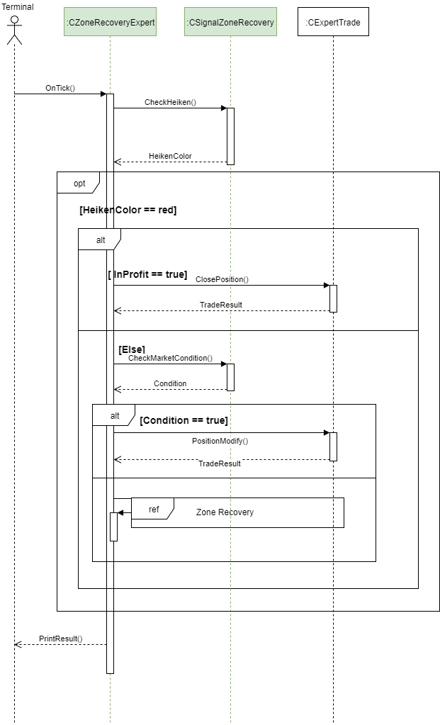

Exit Criteria: Sequence Diagram

## Appendix B - User Interface Design

Not Applicable for this project. The only user interface is the MetaTrader 5 terminal. But that was created by MetaTrader.

## Appendix C - Sprint Review Reports

**Sprint Review Meeting Minutes: Sprint 2**

Attendees: Josue Mirtil, Kyle Roque, Masoud Sadjadi

Start time: 1:30pm

End time: 1:45pm

After a show and tell presentation, the implementation of the following user stories were accepted by the product owners: All.

* N/A

The following ones were rejected and moved back to the product backlog to be assigned to a future sprint at a future Spring Planning meeting.

* User Story <#667 Implement Indicators for Heiken Ashi>
* User Story <#668 Implement Indicators for MACD>
* User Story <#669 Implement Entry Condition Check>
* User Story <#670 Implement Recovery Zoe activity>
* User Story <#671 Implement Exit Criteria>

**Sprint Review Meeting Minutes: Sprint 3**

Attendees: Josue Mirtil, Masoud Sadjadi

Start time: 1:30pm

End time: 2:10pm

After a show and tell presentation, the implementation of the following user stories were accepted by the product owners: All.

* User Story <#669 Implement Entry Condition Check>
* User Story <#667 Implement Indicators for Heiken Ashi>

The following ones were rejected and moved back to the product backlog to be assigned to a future sprint at a future Spring Planning meeting.

* User Story <#669 Implement Entry Condition Check>
* User Story <#670 Implement Recovery Zoe activity>
* User Story <#671 Implement Exit Criteria>

**Sprint Review Meeting Minutes: Sprint 4**

Attendees: Josue Mirtil, Masoud Sadjadi

Start time: 1:30pm

End time: 2:10pm

After a show and tell presentation, the implementation of the following user stories were accepted by the product owners: All.

* User Story <#667 Implement Indicators for Heiken Ashi>
* User Story <#668 Implement Indicators for MACD>
* User Story <#669 Implement Entry Condition Check>
* User Story <#670 Implement Recovery Zone activity>
* User Story <#671 Implement Exit Criteria>

## Appendix D - User Manuals, Installation/Maintenance Document, Shortcomings/Wishlist Document and other documents

## User Manual

Adding new files:

* New Expert Advisers must be added in the Expert folder.
* Indicators must reside in the Indicators folder.
* Indicator classes must reside in the Include/Indicators folder. These classes are the indicator interface that the trade signal uses to communicate with.
* Trade Signals must reside in the Include/Expert/Signal folder.
* Using the MQL5 wizard will properly place the files in the appropriate location.

Using Strategy tester and running the Expert Adviser:

* Follow the guide in the link: https://www.metatrader5.com/en/terminal/help/acc_open. Using the broker mention in the link will allow the use of hedging and filling trades.
* A helpful guide to run the test can be found here: https://www.metatrader5.com/en/terminal/help/testing
* The server used for demo in this project is access.metrader5.com:443. This server allows hedging and trading. Any server with these characteristics can be used, the default server, AMPGlobalClearing is not compatable.

## Installation

* Download MetaTrader 5 at [www.MQL5.com](http://www.mql5.com)
* Open MetaTrader and access MetaEditor via the button on the toolbar. See Figure 1

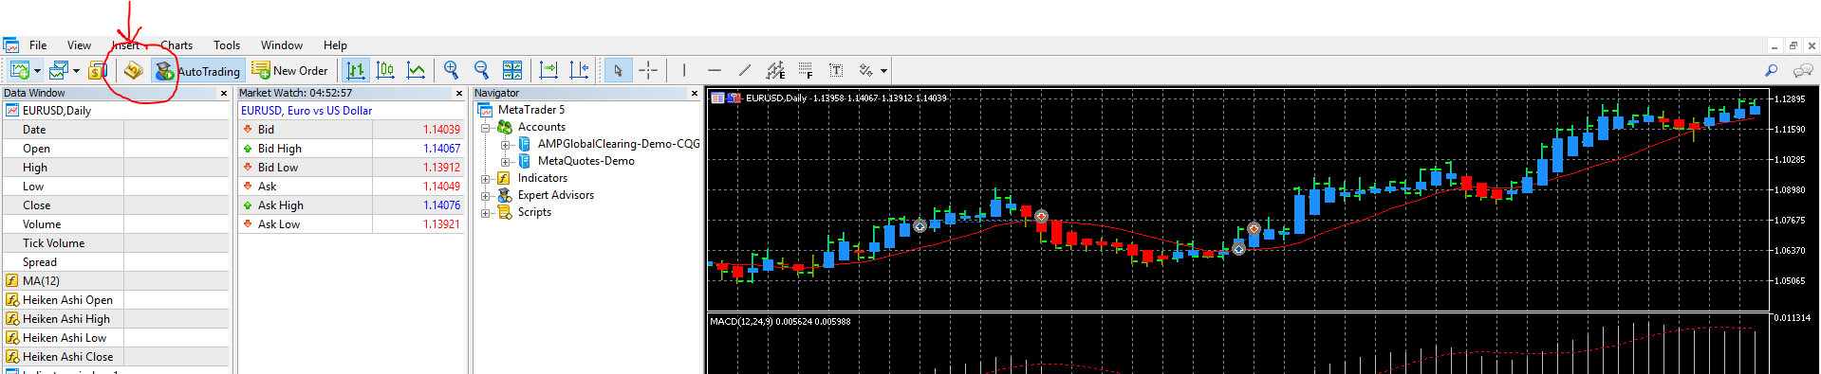

*Figure 1: MetaTrader Window*

* Download repository from github and move and replace the code in the MQL5 directory found in the Navigator window. Right click MQL5 and select open folder to access file location. See Figure 2

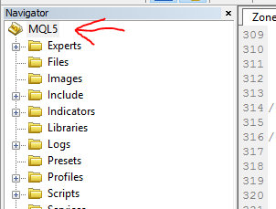

*Figure 2: MetaEditor Navigator Window*

# Shortcomings/Wishlist

One thing missing from this project is a better suited money management system. One where the account can be partitioned into what the user is willing to use for trades at the moment. Then out of those partition trade with ⅕ like mentioned in Joseph Nemeth’s video.

# 

# 

# 

# 

# 

# 

# 

# 

# References

Staff, Investopedia. "Exponential Moving Average - EMA." Investopedia. Investopedia, 18 Nov. 2003. Web. 16 July 2017.

Staff, Investopedia. "Moving Average Convergence Divergence - MACD." Investopedia. Investopedia, 03 Dec. 2015. Web. 16 July 2017.

Young, Andrew R. Expert Advisor Programming for MetaTrader 5: Creating Automated Trading Systems in the MQL5 Language. Nashville, TN: Edgehill, 2013. Print.